Q1

Q2

Q3

Q4

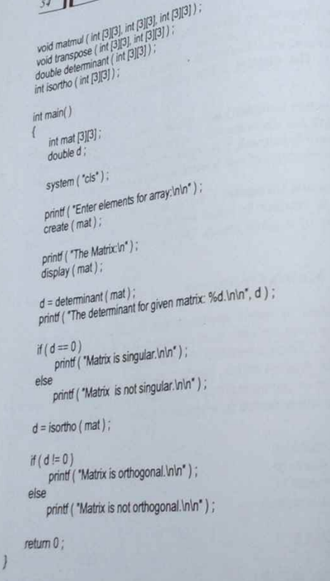

Q5

Q6

